LESSON 8.
Microbiology diagnosis of Tuberculosis, Lepra, Actinomycosis and Nocardiosis

LESSON PLAN:
• General characteristics, classification of bacteria from the genus Mycobacterium.
• Tuberculosis agents, morpho-biological characteristics, pathogenicity factors. Drug resistance. Multidrug-resistant (MDR), extensively drug-resistant (XDR), pandrug-resistant (PDR). Pathogenesis of the disease. Microbiological diagnosis (microscopic, bacteriological, biological, serological, molecular-genetic methods and skin-allergic test). Application of automated cultivation systems in the microbiological diagnosis of tuberculosis. Specific prevention and treatment of tuberculosis. BCG vaccine.
• The causative agent of leprosy. Morpho-biological features, distinguishing features from other mycobacteria, pathogenicity factors, ways of infection, pathogenesis, clinical forms. Microbiological diagnosis of leprosy (microscopic, skin-allergic, molecular-genetic methods), principles of specific treatment and prevention
• Actinomycetes, classification, morpho-biological characteristics, pathogenicity factors. Pathogenesis, clinical forms and microbiological diagnosis of actinomycosis.
• Nocardia, their role in human pathology

MYCOBACTERIUM TUBERCULOSIS
Trigger Words
Acid-fast, lipid-rich cell wall, intracellular, purified protein derivative (PPD), drug-resistant

Biology and Virulence
ᑏ Weakly gram-positive, strongly acid-fast, aerobic rods
ᑏᑏ Lipid-rich cell wall, making the organism resistant to traditional stains, disinfectants, detergents, common antibacterial antibiotics, and host immune response
ᑏᑏ Capable of intracellular growth in alveolar macrophages
ᑏᑏ Disease primarily from host response to infection

Epidemiology
ᑏᑏ Worldwide; one-fourth of the world’s population is infected with this organism
ᑏᑏ A total of 10.4 million new cases each year and 1.6 million deaths
ᑏᑏ Disease most common in India, Pakistan, sub-Saharan Africa, South Africa, China, and Eastern Europe
ᑏᑏ 9272 new cases in the United States in 2016
ᑏᑏ Populations at greatest risk for disease are foreign born or travelers to endemic countries, immunocompromised patients (particularly those with HIV infection), drug or alcohol abusers, homeless persons, and individuals exposed to diseased patients
ᑏᑏ Humans are the only natural reservoir
ᑏᑏ Person-to-person spread by infectious aerosols

Diseases
ᑏᑏ Primary infection is pulmonary
ᑏᑏ Dissemination to anybody site occurs most commonly in immunocompromised patients
Diagnosis
ᑏᑏ Tuberculin skin test and interferon (IFN)-γ release tests are sensitive markers for exposure to the organism
ᑏ Microscopy and culture are sensitive and specific
ᑏᑏ Nucleic acid amplification tests are important where culture is not available and microscopy is inaccurate for detection of M. tuberculosis in clinical specimens
ᑏᑏ Identification most commonly made using species-specific molecular probes, sequencing, or mass spectrometry

Treatment, Prevention, and Control
ᑏᑏ Prolonged treatment with multiple drugs is required to prevent development of drug-resistant strains
ᑏᑏ Isoniazid (INH), ethambutol, pyrazinamide, and rifampin for 2 months followed by 4-6 months of INH and rifampin or alternative combination drugs
ᑏᑏ Prophylaxis for exposure to tuberculosis can include INH for 6-9 months or daily rifampin for 4 months; pyrazinamide and ethambutol or levofloxacin are used for 6-12 months after exposure to drugresistant M. tuberculosis
ᑏᑏ Immunoprophylaxis with bacillus Calmette-Guérin (BCG) in endemic countries
ᑏᑏ Control of disease through active surveillance, prophylactic and therapeutic intervention, and careful case monitoring

MYCOBACTERIUM LEPRAE
Trigger Words
Acid-fast, leprosy, nonculturable, skin test

Biology and Virulence
ᑏᑏ Weakly gram-positive, strongly acid-fast rods
ᑏᑏ Lipid-rich cell wall
ᑏᑏUnable to be cultured on artificial media
ᑏᑏ Disease primarily from host response to infection

Epidemiology
ᑏᑏ 200,000 new cases were reported in 2016, with most cases in India, Brazil, and Indonesia
ᑏᑏ 178 new cases reported in the United States in 2015
ᑏᑏ Lepromatous form of disease, but not the tuberculoid form, is highly infectious
ᑏᑏ Person-to-person spread by prolonged exposure to respiratory secretions of an untreated, infected person

Diseases
ᑏᑏ Tuberculoid (paucibacillary) and lepromatous (multibacillary) forms of leprosy

Diagnosis
ᑏᑏ Microscopy is sensitive for the lepromatous form but not the tuberculoid form
ᑏᑏ Skin testing is required to confirm tuberculoid leprosy
ᑏᑏCulture is not useful

Treatment, Prevention, and Control
ᑏᑏ Tuberculoid form is treated with rifampicin and dapsone for 6 months; clofazimine is added to this regimen for treatment of the lepromatous form, and therapy is extended to a minimum of 12 months
ᑏᑏ Disease is controlled through prompt recognition and treatment of infected people

MYCOBACTERIUM AVIUM COMPLEX
Trigger Words
Acid-fast, pulmonary infections, AIDS, prophylaxis

Biology and Virulence
ᑏᑏ Weakly gram-positive, strongly acid-fast aerobic rods
ᑏᑏ Lipid-rich cell wall
ᑏᑏ Disease primarily from host response to infection

Epidemiology
ᑏ Worldwide distribution, but disease is seen most commonly in countries where tuberculosis is less common
ᑏᑏ Acquired primarily through ingestion of contaminated water or food; inhalation of infectious aerosols is believed to play a minor role in transmission
ᑏᑏ Patients at greatest risk for disease are those who are immunocompromised (particularly patients with acquired immunodeficiency syndrome [AIDS]) and those with long-standing pulmonary disease

Diseases
ᑏᑏ Disease includes asymptomatic colonization, chronic localized pulmonary disease, solitary nodule, or disseminated disease, particularly in patients with AIDS

Diagnosis
ᑏᑏ Microscopy and culture are sensitive and specific

Treatment, Prevention, and Control
ᑏᑏ Infections treated for prolonged period with clarithromycin or azithromycin combined with ethambutol and rifabutin
ᑏᑏ Prophylaxis in AIDS patients who have a low CD4 cell count consists of clarithromycin or azithromycin or rifabutin, and such treatment has greatly reduced the incidence of disease

NOCARDIA
Trigger Words
Modified acid-fast, filamentous, bronchopulmonary or cutaneous disease, opportunistic

Biology and Virulence
ᑏᑏ Gram-positive, partially acid-fast, filamentous rods; cell wall with mycolic acid
ᑏᑏ Strict aerobe capable of growth on most nonselective bacteria, fungal, and mycobacterial media; however, prolonged incubation (2 days or more) may be required
ᑏᑏ Virulence associated with ability to avoid intracellular killing
ᑏᑏ Catalase and superoxide dismutase inactivate toxic oxygen metabolites (e.g.,hydrogen peroxide, superoxide)
ᑏᑏ Cord factor prevents intracellular killing in phagocytes by interfering with fusion of phagosomes with lysosomes

Epidemiology
ᑏᑏ Worldwide distribution in soil rich with organic matter
ᑏᑏ Exogenous infections acquired by inhalation (pulmonary) or traumatic introduction (cutaneous)
ᑏᑏ Opportunistic pathogen causing disease most commonly in immunocompromised patients with T-cell deficiencies (transplant recipients, patients with malignancies, patients infected with the human immunodeficiency virus [HIV], patients receiving corticosteroids)

Diseases
ᑏᑏ Primary disease most commonly bronchopulmonary (e.g., cavitary disease) or primary cutaneous infections (e.g.,mycetoma, lymphocutaneous infection, cellulitis, subcutaneous abscesses)
ᑏᑏ Dissemination most commonly to central nervous system (e.g., brain abscesses) or skin

Diagnosis
ᑏᑏ Microscopy is sensitive and relatively specific when branching, partially acidfast organisms are seen
ᑏᑏ Culture is slow, requiring incubation for up to 1 week; selective media (e.g., buffered charcoal yeast extract agar) may be required for isolating Nocardia in mixed cultures
ᑏᑏ Identification at the genus level can be made by the microscopic and macroscopic appearances (branching, weakly acid-fast rods forming colonies with aerial hyphae)
ᑏᑏ Identification at the species level requires genomic analysis for most isolates or mass spectrometry
Treatment, Prevention, and Control
ᑏᑏ Infections are treated with antibiotics and proper wound care
ᑏᑏ Trimethoprim-sulfamethoxazole (TMP-SMX) used as initial empirical therapy for cutaneous infections in immunocompetent patients; therapy for severe infections and cutaneous infections in immunocompromised patients should include TMP-SMX plus amikacin for pulmonary or cutaneous infections and TMP-SMX plus imipenem or a cephalosporin for central nervous system infections; prolonged treatment (up to 12 months) is recommended
ᑏᑏ Exposure cannot be avoided because nocardiae are ubiquitous

Important Acid-Fast Bacteria
Mycobacterium - myces, a fungus; bakterion, a small rod (fungus-like rod)
M. abscessus - abscessus, of abscesses (causes abscess formation)
M. avium - avis, of birds (causes tuberculosis-like illness in birds)
M. chelonae - chelone, a tortoise (initial source)
M. fortuitum - fortuitum, casual, accidental (refers to the fact that this is an opportunistic pathogen)
M. haemophilum - haema, blood; philos, loving (blood loving; refers to requirement for blood or hemin for in vitro growth)
M. intracellulare - intra, within; cella, small room (within cells; refers to the intracellular location of this and all mycobacteria)
M. kansasii - kansasii, of Kansas (where the organism was originally isolated)
M. leprae lepra, of leprosy (the cause of leprosy)
M. marinum - marinum, of the sea (bacterium associated with contaminated freshwater and saltwater)
M. tuberculosis - tuberculum, a small swelling or tubercle; osis (characterized by tubercles; refers to the formation of tubercles in the lungs of infected patients)
Nocardia Named after the French veterinarian Edmond No card
Rhodococcus - rhodo, rose or red colored; coccus, berry (red colored coccus)
Gordonia - Named after the American microbiologist Ruth Gordon
Tsukamurella - Honoring the Japanese microbiologist Michio Tsukamura, who first described the original isolate of this genus

Classification of Selected Acid-Fast Bacteria Pathogenic for Humans
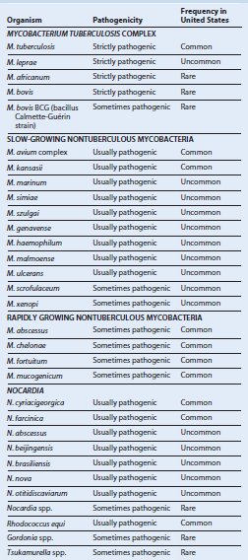

Clinical and Immunologic Manifestations of Leprosy
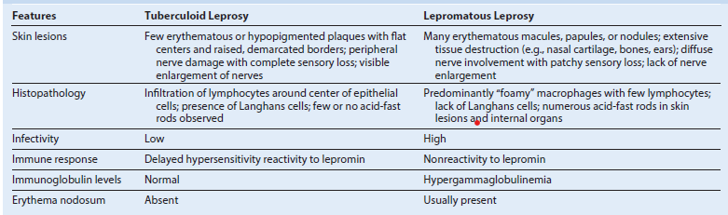

Diseases of Selected Pathogenic Actinomycetes
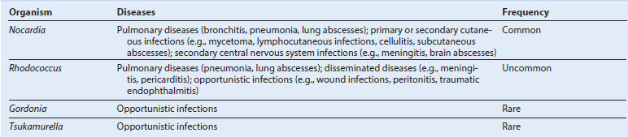

Nocardiosis: Clinical Summaries
Bronchopulmonary disease: indolent pulmonary disease with necrosis and abscess formation; dissemination to central nervous
system or skin is common
Mycetoma: chronic destructive progressive disease, generally of extremities, characterized by suppurative granulomas, progressive
fibrosis and necrosis, and sinus tract formation
Lymphocutaneous disease: primary infection or secondary spread to cutaneous site, characterized by chronic granuloma formation and erythematous subcutaneous nodules, with eventual ulcer formation
Cellulitis and subcutaneous abscesses: granulomatous ulcer formation with surrounding erythema but minimal or no involvement of the draining lymph nodes
Brain abscess: chronic infection with fever, headache, and focal deficits related to the location of the slowly developing abscess(es)

